

BHYAL

PDR SERVİSİ

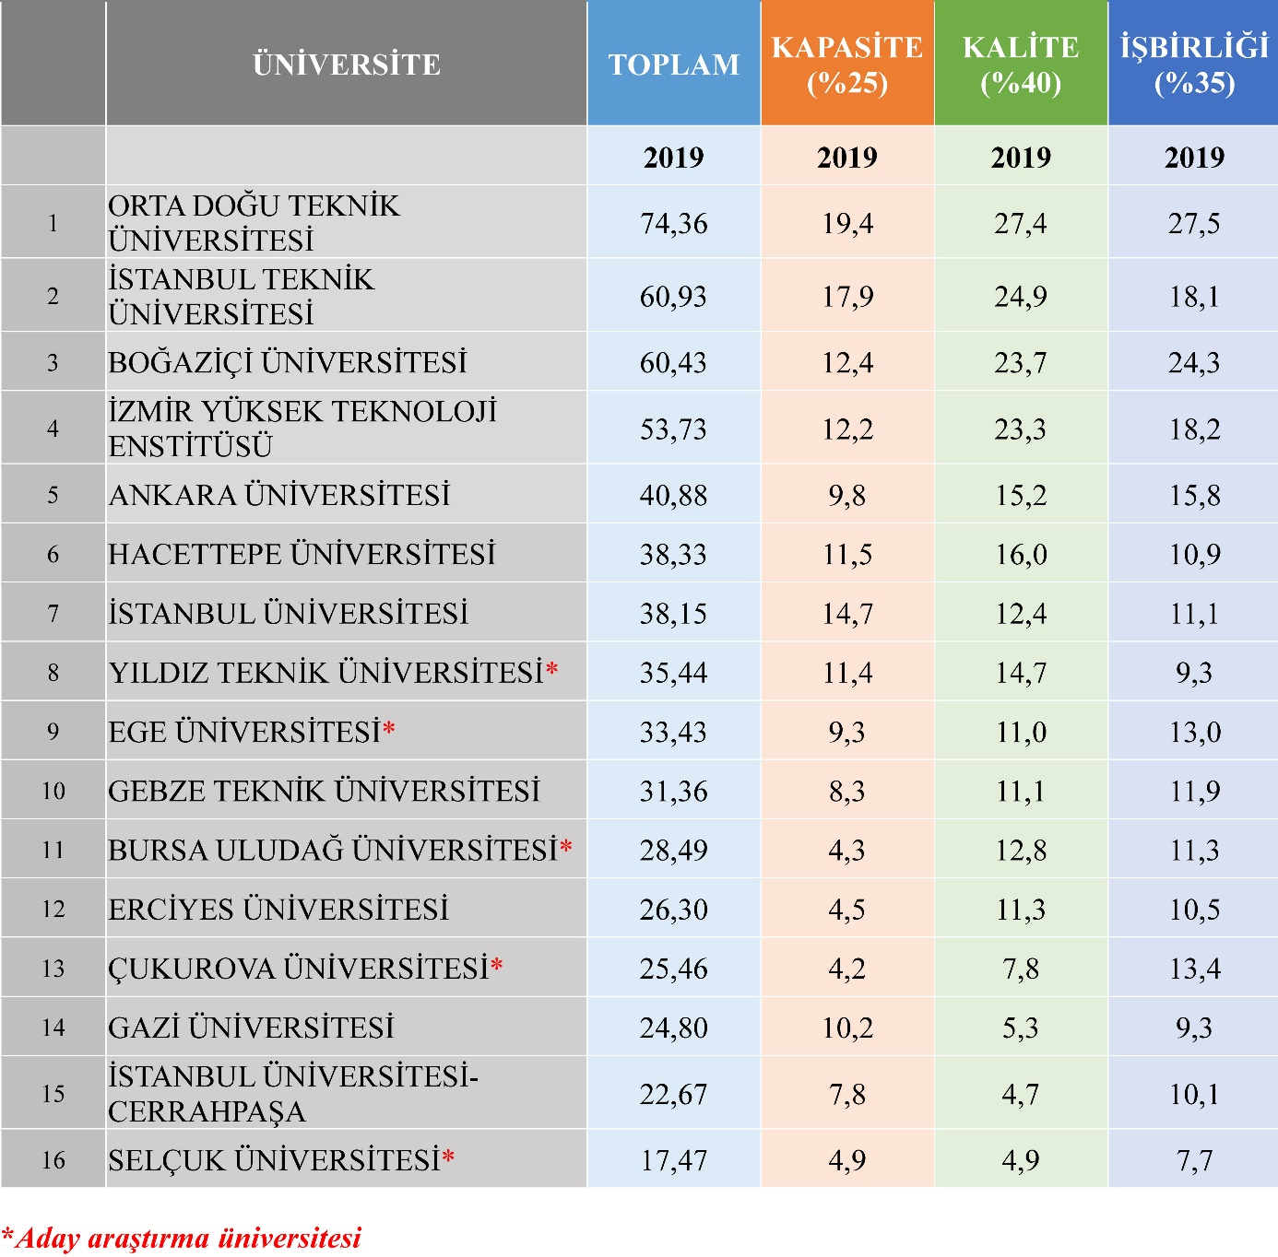

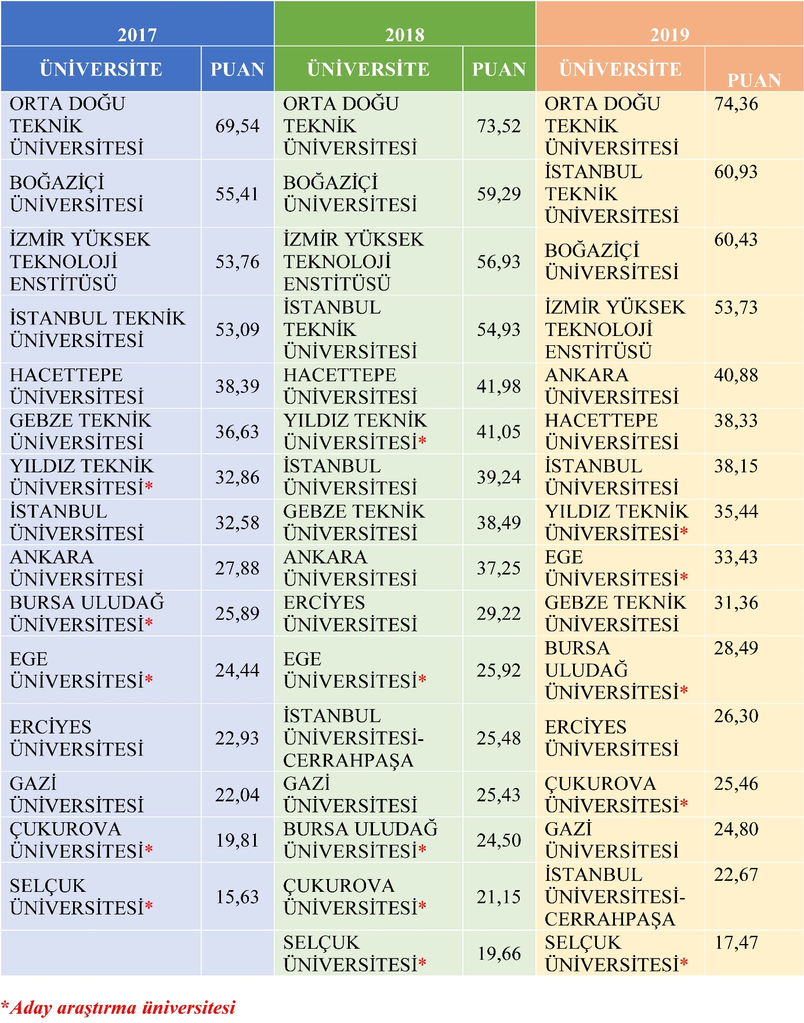

|  |
| --- |
| BÜYÜKŞEHİR HÜSEYİN YILDIZ ANADOLU LİSESİ |
| İLHAN DAĞHAN(PDR) |

